**Answer Sheet - SQL**

Name : MONALISHA SHUKLA

Phone No. : 9437726276

Email : mona.9439447731@gmail.com

**Major Question 1**

1. List the salary of all the employees.

SELECT SALARY

FROM EMPLOYEE;

Insert Image-

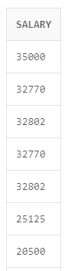

1. Display the names of all employees with any “A” at any place of the name.

SELECT*FROM EMPLOYEE

WHERE ENAME LIKE'%A%';

Insert Image –

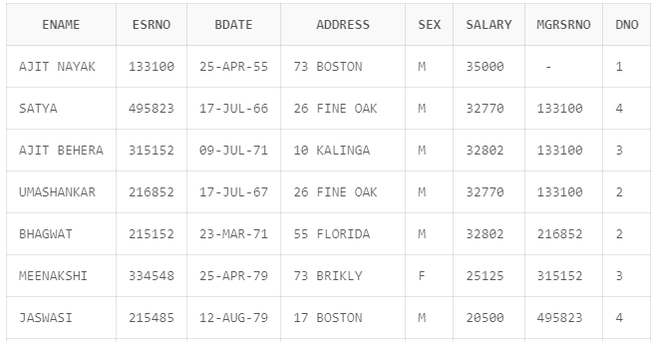

1. Show all employees who were hired in the first half of the month (Before the 16th of the month).

SELECT ENAME,MGRSTARTD FROM EMPLOYEE INNER JOIN DEPARTMENT

ON EMPLOYEE.MGRSRNO=DEPARTMENT.MGRSRNO;

Insert Image -

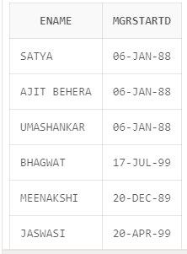

1. Display the name of all female employees.

SELECT ENAME,SEX FROM EMPLOYEE WHERE SEX='F';

Insert Image -

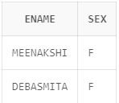

1. Display the employee who is paid most in the company.

SELECT ENAME,MAX(SALARY)FROM EMPLOYEE

WHERE SALARY=(SELECT MAX(SALARY)FROM EMPLOYEE)

GROUP BY ENAME,SALARY;

Insert Image –

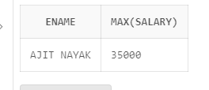

**Major Question 2**

1. Display employee name, address, department no and department name.

<answer-here>SELECT E.ENAME,E.ADDRESS,E.DNO,D.DNAME

FROM E.EMLOYEE E,DEPARTMENT D

WHERE E.DNAME=D.DNAME;

Insert Image –

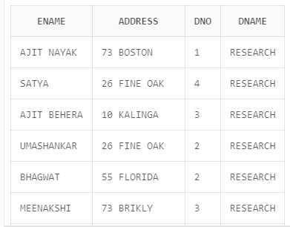

1. Display all the employees who are *not in* ACADEMIC department

SELECT EMPLOYEE.ENAME,DEPARTMENT.DNAME FROM EMPLOYEE,DEPARTMENT

WHERE DNAME!='ACADEMIC' AND EMPLOYEE.DNO=DEPARTMENT.DNUMBER;

Insert Image –

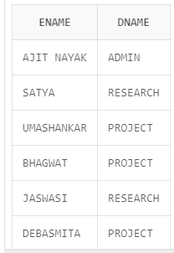

1. Display SATYAS’ project location.

SELECT EMPLOYEE.ENAME,PROJECT.PLOCATION FROM EMPLOYEE,PROJECT

WHERE ENAME='SATYA'AND EMPLOYEE.DNO=PROJECT.DNUM;

Insert Image -

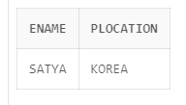

1. Find the total working hours of *each* female employee.

SELECT ENAME,SUM(HOURS)FROM EMPLOYEE INNER JOIN WORKS_ON ON

EMPLOYEE.ESRNO=WORKS_ON.ESRNO

WHERE SEX='F'

GROUP BY ENAME,SEX;

Insert Image -

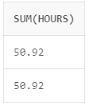

1. Display the details of the people whose projects are located at SOUTH AFRICA.

SELECT *from employee inner join project on employee.dno=project.dnum

where plocation='SOUTH AFRICA';

Insert Image -

